

RAMAIAH
INSTITUTE OF TECHNOLOGY
USN | 1 | M | S

(Autonomous Institute, Affiliated to VTU)
Bangalore – 560 054

MAKE UP EXAMINATIONS – FEBRUARY 2017
Course & Branch | : | B.E : Common to all branches | Semester | : | I/II
Subject | : | Basic Electronics | Max. Marks | : | 100
Subject Code | : | EC101/EC201 | Duration | : | 3 Hrs

Instructions to the Candidates:
- Answer one full question from each unit.

 |  | UNIT - I
1. | a) | Explain the working of full Wave Bridge Rectifier. Sketch the relevant waveforms. Derive the equations for Idc, Irms and ripple factor. | CO1 | (08)
 | b) | Explain the working of the positive clipper with a neat circuit diagram and draw the input and output waveforms. | CO1 | (06)
 | c) | Define the common base and common emitter current gain factor and bring out the relationship between them. Given common emitter current gain factor as 50 and emitter current is 120 mA. Find collector and base current. | CO1 | (06)
2. | a) | Draw and explain the operation of the circuit that clamps the output to negative peak and draw the input and output waveforms for a sinusoidal signal. | CO1 | (06)
 | b) | With a neat circuit diagram, explain the working of Line regulation in Zener regulator. In a Zener regulator, the input DC is 10V±20%. The output requirements are 5V, 20mA. Assuming I_{zmax} & I_{zmin} as 80mA and 5mA respectively. Design Zener regulator? | CO1 | (08)
 | c) | With a neat circuit diagram, explain the Common Emitter input and output characteristics. | CO1 | (06)
 |  | UNIT -II
3. | a) | For the circuit shown in fig 3a, determine Ic, V_{E}, V_{B} and R₁. (use approximate analysis)  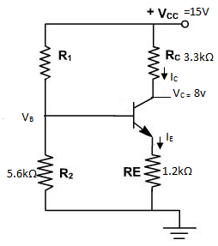 | CO1 | (06)
 | b) | Derive an expression for a output of a 3 input summing inverting operational amplifier.  i) Determine the condition for finding the average of the inputs  ii)Determine the output when  V₁=+1V, V₂=+2V, V₃=+3V , R₁=500kΩ, R₂=1MΩ , R₃=1MΩ | CO2 | (09)
 | c) | Draw and explain collector to base bias circuit. | CO1 | (05)
4. | a) | Compare the three biasing circuits. | CO1 | (06)
 | b) | Design a fixed bias circuit using silicon transistor having β=100, V_{CC} is 10V, V_{CE}=5V and I_{C}=5mA. | CO1 | (07)
 | c) | With neat circuit and waveforms obtain the expression for output of op-amp differentiator. | CO2 | (04)
 | d) | Explain the terms output impedance, slew rate and CMRR. | CO2 | (03)
 |  | UNIT - III
5. | a) | Convert the binary number 111111001.00111101 into decimal, octal and hexadecimal number systems. | CO3 | (06)
 | b) | Simplify the Boolean expression and realize using basic gates.  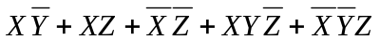 | CO3 | (07)
 | c) | Design a full adder using only NAND gates. | CO3 | (07)
6. | a) | Perform the following:  i) (11.125)₁₀ = ( )₂  ii) (725.25)₈ = ( )₁₀ = ( )₁₆  iii) (2AC5.D)_{H} = ( )₂  iv) 2’s compliment of (10111011)₂ | CO3 | (10)
 | b) | Implement the Boolean expression using NOR gates for  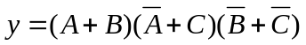 | CO3 | (05)
 | c) | Write the Boolean expression for the output Y and write the truth table.  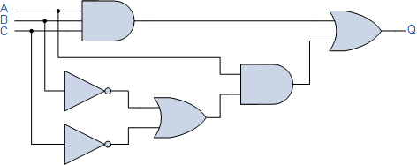  Y | CO3 | (05)
 |  | UNIT -IV
7. | a) | Differentiate between Latches and Flipflops. | CO4 | (06)
 | b) | Design and explain clocked RS flipflop using NAND gates. Draw the waveform for each combination of the inputs. | CO4 | (08)
 | c) | Explain the features of 8051 microcontroller. | CO4 | (06)
8. | a) | Design and realize SR latch using NOR gates. Draw the waveform for each combination of the inputs. | CO4 | (08)
 | b) | With neat block diagram, explain the architecture of 8051 microcontroller. | CO4 | (08)
 | c) | Differentiate between combinational and sequential circuits. | CO4 | (04)
 |  | UNIT - V
9. | a) | Explain the need for modulation. Illustrate with example. | CO5 | (06)
 | b) | An audio frequency signal 5sin2πx1000t is used to amplitude modulate a carrier of 25sin2πx10⁵t. Calculate: Modulation index, Sideband frequencies, Bandwidth required, Amplitude of each sideband frequency and total power delivered to the load of 300Ω. | CO5 | (06)
 | c) | Describe the operation of a piezo-electric and photo-electric transducer with neat diagrams. | CO5 | (08)
10. | a) | Define Amplitude Modulation. Derive the output expression for single tone AM signal and draw its frequency spectrum. | CO5 | (08)
 | b) | Compare Amplitude Modulation and Frequency Modulation. | CO5 | (06)
 | c) | Explain the principle and operation of LVDT with neat diagrams. | CO5 | (06)
****************

